**INTRODUCTION TO COMPUTER HARDWARE**

All physical components that make up a computer is known as computer hardware.It includes all components that we can see and touch i.e. processor, input devices like keyboard, mouse, output devices like visual display unit (VDU), printer, speaker, connecting wires, casing, storage devices etc. Block diagram depicting major components of computer is shown below:

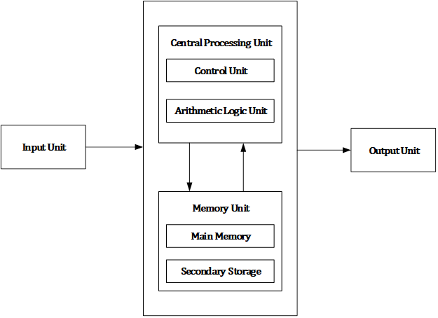

Figure: Computer Block Diagram

Computer hardware consists of different functional units: input unit, central processing unit (CPU) which consists arithmetic logic unit (ALU) and control unit (CU), memory unit and output unit.

Computer accepts digital data from user with the help of input devices like mouse, keyboard, microphone etc. Received data from user is either stored in the memory for later use or immediately processed by the arithmetic and logic unit to carry out the desired operations. After processing, processed output known as information is either stored in memory for later use or sent to user with the help of output devices like monitor, printer, speaker etc. All the above mentioned activities are controlled and coordinated by the control unit.

**PHYSICAL IDENTIFICATION OF MAJOR COMPONENTS OF A COMPUTER SYSTEM**

1. **MOTHERBOARD**

The motherboard is at the center of what makes a PC work. It houses the CPU and is a hub that all other hardware runs through. The motherboard acts as a brain; allocating power where it’s needed, communicating with and coordinating across all other components – making it one of the most important pieces of hardware in a computer.

When choosing a motherboard, it’s important to check what hardware ports the motherboard supplies. It’s vital to check how many USB ports, and what grade (USB 2.0, 3.0, 3.1) they are, as well as what display ports are used (HDMI, DVI, RGB) and how many of each there are. The ports on the motherboard will also help you define what other hardware will be compatible with your computer, such as what type of RAM and graphics card you can use.

Although the motherboard is just one piece of circuitry, it is home to another one of the most important pieces of hardware: the processor.

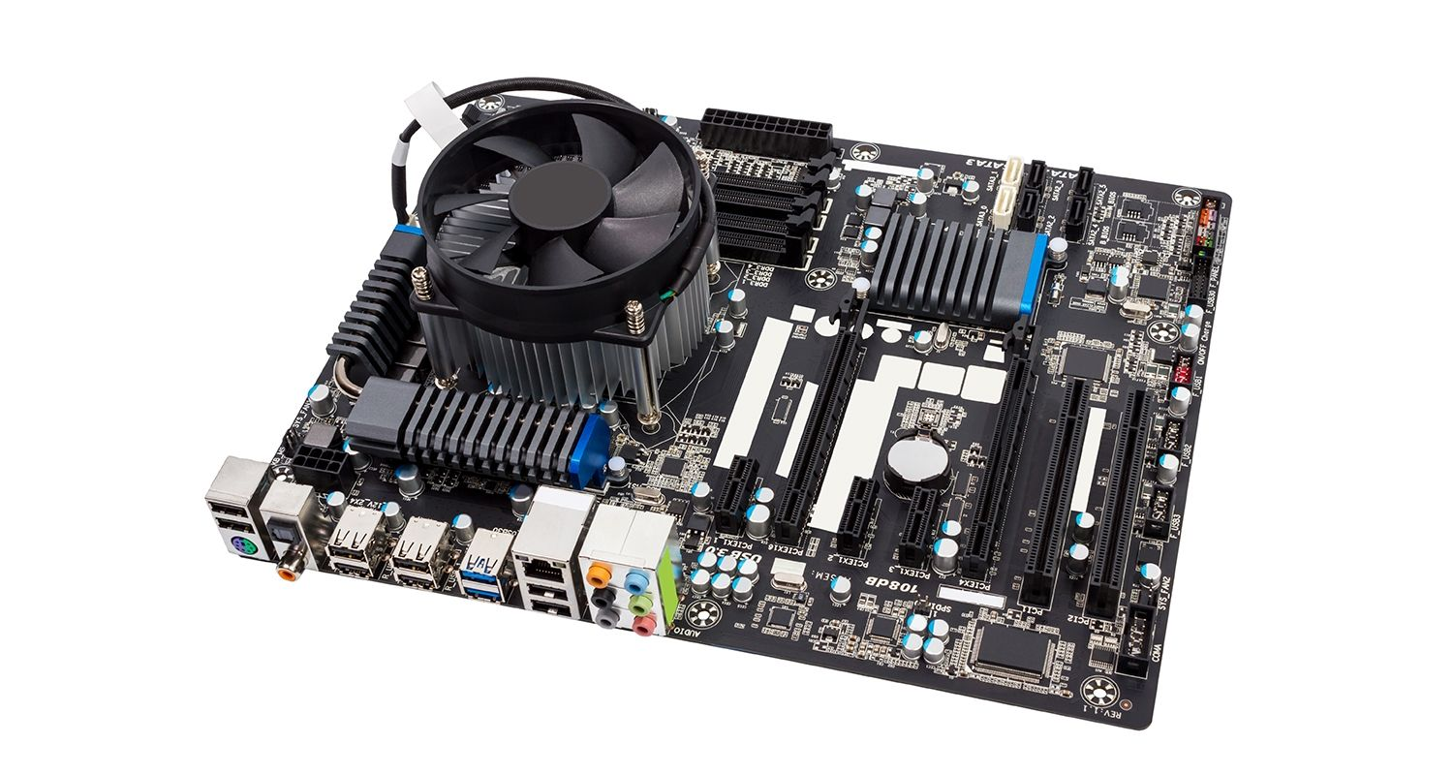

1. **RAM MODULES**

Random Access Memory, or RAM, is hardware found in the memory slots of the motherboard. The role of RAM is to temporarily store on-the-fly information created by programs and to do so in a way that makes this data immediately accessible. The tasks that require random memory could be; rendering images for graphic design, edited video or photographs, multi-tasking with multiple apps open (for example, running a game on one screen and chatting via Discord on the other).

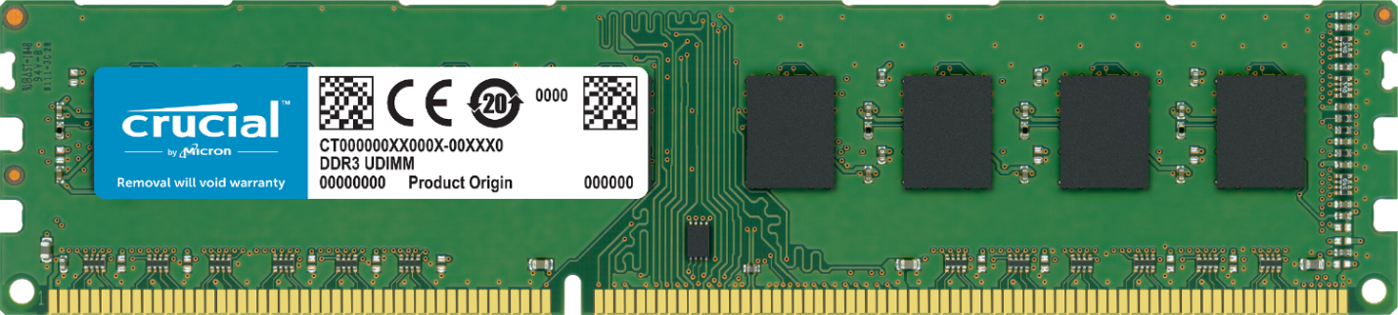

1. **DAUGHTER CARD**

A daughterboard (or *daughter board* , *daughter card* , or *daughtercard* ) is a circuit board that plugs into and extends the circuitry of another circuit board. The other circuit board may be the computer's main board (its motherboard ) or it may be another board or card that is already in the computer, often a sound card. The term is commonly used by manufacturers of wavetable daughterboards that attach to existing sound cards.

A mezzanine card is a kind of daughterboard that is installed in the same plane as but on a second level above the motherboard.

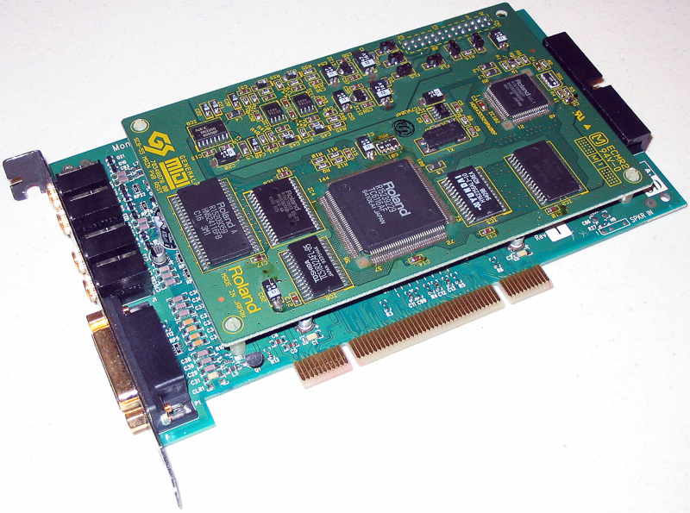

1. **BUS SLOT**

Alternatively known as a **bus slot** or **expansion port**, an **expansion slot** is a connection or port inside a [computer](https://www.computerhope.com/jargon/c/computer.htm) on the [motherboard](https://www.computerhope.com/jargon/m/mothboar.htm) or [riser card](https://www.computerhope.com/jargon/r/risecard.htm). It provides an installation point for a hardware expansion card to be connected. For example, if you wanted to install a new video card in the computer, you'd purchase a video expansion card and install that card into the compatible expansion slot.

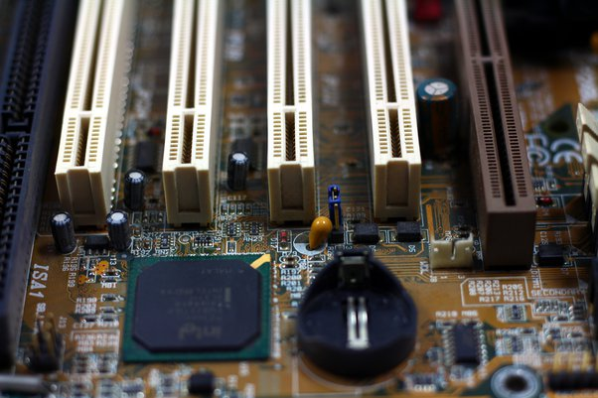

1. **SMPS**

A switched-mode power supply (SMPS) is an electronic circuit that converts power using switching devices that are turned on and off at high frequencies, and storage components such as inductors or capacitors to supply power when the switching device is in its non-conduction state.

Switching power supplies have high efficiency and are widely used in a variety of electronic equipment, including computers and other sensitive equipment requiring stable and efficient power supply.

A switched-mode power supply is also known as a switch-mode power supply or switching-mode power supply.

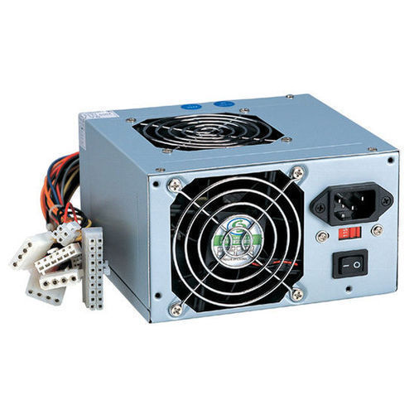

1. **INTERNAL STORAGE DEVICES**

Some storage devices are classed as 'internal' which means they are inside the computer case.Most computers have some form of internal storage. The most common type of internal storage is the hard disk.At the most basic level, internal storage is needed to hold the operating system so that the computer is able to access the input and output devices.

It will also be used to store the applications software that you use and more than likely, the original copies of your data files.

Internal storage allows the data and applications to be loaded very rapidly into memory, ready for use. The data can be accessed much faster than data which is stored on an external storage device. This is because internal storage devices are connected directly to the motherboard and its data bus whereas external devices are connected through a hardware interface such as USB, which means they are considerably slower to access.

Internal storage also means that if the computer is moved around, it will still retain its most commonly used data.The main disadvantage of internal storage is that when the hard disk fails (and it will), all the data and applications may be lost.This can be avoided to some extent by using more than one hard disk within the machine. Each hard disk has a copy of all the data, so if one fails the other can carry on. This is called a RAID array. An alternative is to use external drives for backup.

1. © www.teach-ict.com

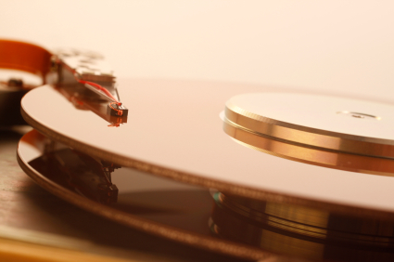

1. **INTERFACE PORTS**

A Computer Port is an interface or a point of connection between the computer and its peripheral devices. Some of the common peripherals are mouse, keyboard, monitor or display unit, printer, speaker, flash drive etc.

The main function of a computer port is to act as a point of attachment, where the cable from the peripheral can be plugged in and allows data to flow from and to the device.

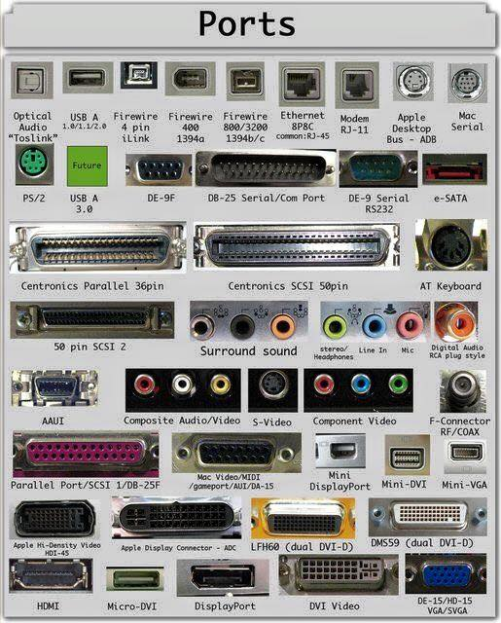

A computer port is also called as a Communication Port as it is responsible for communication between the computer and its peripheral device. Generally, the female end of the connector is referred to as a port and it usually sits on the motherboard.

In Computers, communication ports can be divided into two types based on the type or protocol used for communication. They are Serial Ports and Parallel Ports.

A serial port is an interface through which peripherals can be connected using a serial protocol which involves the transmission of data one bit at a time over a single communication line. The most common type of serial port is a D-Subminiature or a D-sub connector that carry RS-232 signals.

A parallel port, on the other hand, is an interface through which the communication between a computer and its peripheral device is in a parallel manner i.e. data is transferred in or out in parallel using more than one communication line or wire. Printer port is an example of parallel port.

**PS/2**

PS/2 connector is developed by IBM for connecting mouse and keyboard. It was introduced with IBM’s Personal Systems/2 series of computers and hence the name PS/2 connector. PS/2 connectors are color coded as purple for keyboard and green for mouse.

[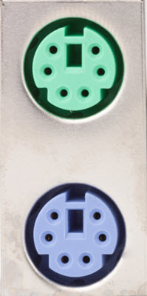](https://www.electronicshub.org/wp-content/uploads/2016/01/PS2-Port.jpg)

PS/2 is a 6-pin DIN connector. The pin out diagram of a PS/2 female connector is shown below.

[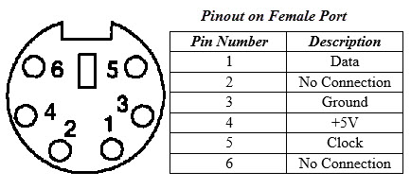](https://www.electronicshub.org/wp-content/uploads/2016/01/PS2-Pinout.jpg)

Even though the pinout of both mouse and keyboard PS/2 ports are same, computers do not recognize the devise when connected to wrong port.PS/2 port is now considered a legacy port as USB port has superseded it and very few of the modern motherboards include it as a legacy port.

**Serial Port**

Even though the communication in PS/2 and USB is serial, technically, the term Serial Port is used to refer the interface that is compliant to RS-232 standard. There are two types of serial ports that are commonly found on a computer: DB-25 and DE-9.

**DB-25**

DB-25 is a variant of D-sub connector and is the original port for RS-232 serial communication. They were developed as the main port for serial connections using RS-232 protocol but most of the applications did not require all the pins.

Hence, DE-9 was developed for RS-232 based serial communication while DB-25 was rarely used as a serial port and often used as a parallel printer port as a replacement of the Centronics Parallel 36 pin connector.

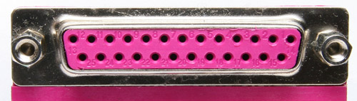

**DE-9 or RS-232 or COM Port**

DE-9 is the main port for RS-232 serial communication. It is a D-sub connector with E shell and is often miscalled as DB-9. A DE-9 port is also called as a COM port and allows full duplex serial communication between the computer and it’s peripheral.

Some of the applications of DE-9 port are serial interface with mouse, keyboard, modem, uninterruptible power supplies (UPS) and other external RS-232 compatible devices.

[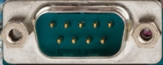](https://www.electronicshub.org/wp-content/uploads/2016/01/DE-9-Port.jpg)

The pinout diagram of DE-9 port is shown below.

[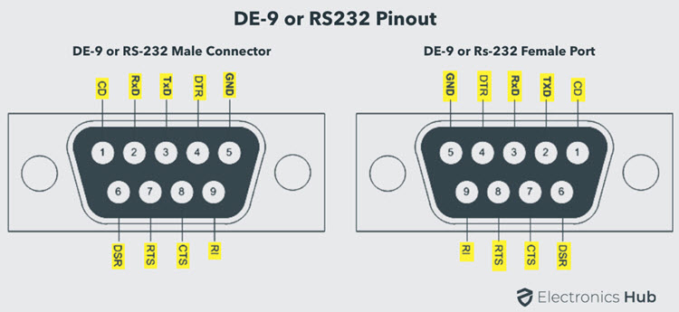](https://www.electronicshub.org/wp-content/uploads/2021/04/DE-9-RS-232-Male-Female-Pinout.jpg)

The use of DB-25 and DE-9 ports for communication is in decline and are replaced by USBs or other ports.

**Parallel Port or Centronics 36 Pin Port**

Parallel port is an interface between computer and peripheral devices like printers with parallel communication. The Centronics port is a 36 pin port that was developed as an interface for printers and scanners and hence a parallel port is also called as a Centronics port.

Before the wide use of USB ports, parallel ports are very common in printers. The Centronics port was later replaced by DB-25 port with parallel interface.

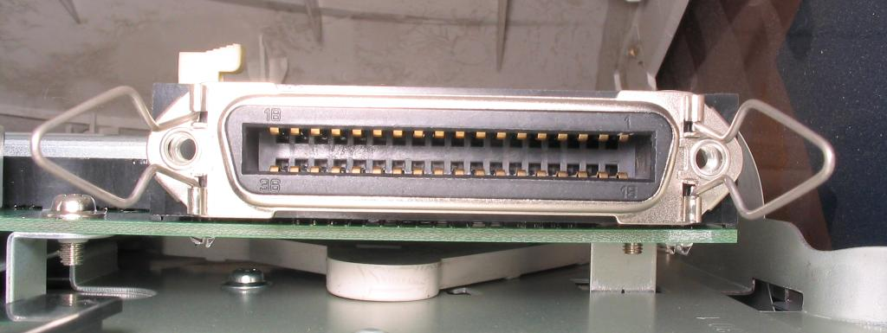

**Audio Ports**

Audio ports are used to connect speakers or other audio output devices with the computer. The audio signals can be either analogue or digital and depending on that the port and its corresponding connector differ.

**Surround Sound Connectors or 3.5 mm TRS Connector**

It is the most commonly found audio port that can be used to connect stereo headphones or surround sound channels. A 6 connector system is included on majority of computers for audio out as well as a microphone connection.

The 6 connectors are color coded as Blue, Lime, Pink, Orange, Black and Grey. These 6 connectors can be used for a surround sound configuration of up to 8 channels.

[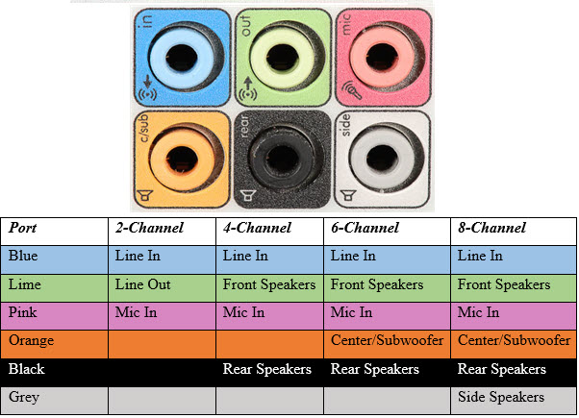](https://www.electronicshub.org/wp-content/uploads/2016/01/Surround-Sound-Ports.jpg)

**S/PDIF / TOSLINK**

The Sony/Phillips Digital Interface Format (S/PDIF) is an audio interconnect used in home media. It supports digital audio and can be transmitted using a coaxial RCA Audio cable or an optical fiber TOSLINK connector.

Most computers home entertainment systems are equipped with S/PDIF over TOSLINK. TOSLINK (Toshiba Link) is most frequently used digital audio port that can support 7.1 channel surround sound with just one cable. In the following image, the port on the right is an S/PDIF port.

[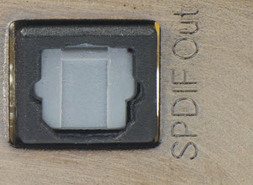](https://www.electronicshub.org/wp-content/uploads/2016/01/SPDIF-Port.jpg)

**Video Ports**

**VGA Port**

VGA port is found in many computers, projectors, video cards and High Definition TVs. It is a D-sub connector consisting of 15 pins in 3 rows. The connector is called as DE-15.

VGA port is the main interface between computers and older CRT monitors. Even the modern LCD and LED monitors support VGA ports but the picture quality is reduced. VGA carries analogue video signals up to a resolution of 648X480.

[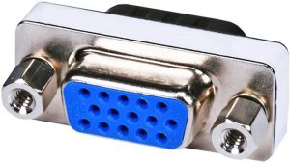](https://www.electronicshub.org/wp-content/uploads/2016/01/VGA-Port.jpg)

With the increase in use of digital video, VGA ports are gradually being replaced by HDMI and Display Ports. Some laptops are equipped with on-board VGA ports in order to connect to external monitors or projectors. The pinout of a VGA port is shown below.

[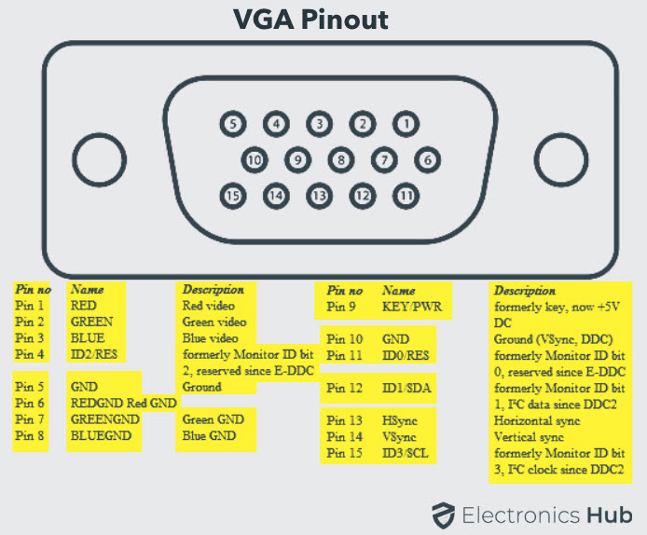](https://www.electronicshub.org/wp-content/uploads/2021/04/VGA-Port-Pinout.jpg)

**Digital Video Interface (DVI)**

DVI is a high speed digital interface between a display controller like a computer and a display device like a monitor. It was developed with an aim of transmitting lossless digital video signals and replace the analogue VGA technology.

[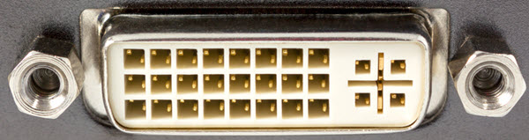](https://www.electronicshub.org/wp-content/uploads/2016/01/DVI-Port.jpg)

There are three types of DVI connectors based on the signals it can carry: DVI-I, DVI-D and DVI-A. DVI-I is a DVI port with integrated analogue and digital signals. DVI-D supports only digital signals and DVI-A supports only analogue signals.

The digital signals can be either single link or dual link where a single link supports a digital signal up to 1920X1080 resolution and a dual link supports a digital signal up to 2560X1600 resolution. The following image compares the structures of DVI-I, DVI-D and DVI-A types along with the pinouts.

[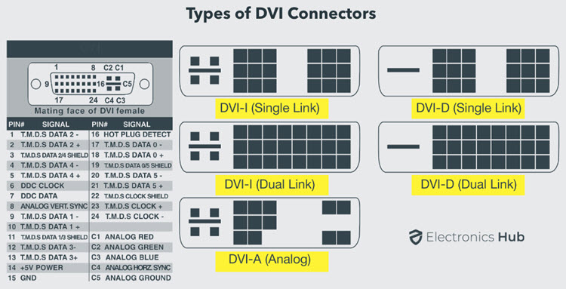](https://www.electronicshub.org/wp-content/uploads/2021/04/Types-of-DVI-Connectors-Pinout.jpg)

**Mini-DVI**

Mini-DVI port is developed by Apple as an alternative to Mini-VGA port and is physically similar to one. It is smaller than a regular DVI port.

It is a 32 pin port and is capable of transmitting DVI, composite, S-Video and VGA signals with respective adapters. The following image shows a Mini-DVI port and its compatible cable.

[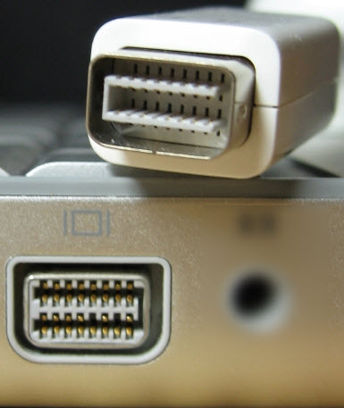](https://www.electronicshub.org/wp-content/uploads/2016/01/Mini-DVI-Port.jpg)

**Micro-DVI**

Micro-DVI port, as the name suggests is physically smaller than Mini-DVI and is capable of transmitting only digital signals.

This port can be connected to external devices with DVI and VGA interfaces and respective adapters are required. In the following image, a Micro-DVI port can be seen adjacent to headphone and USB ports.

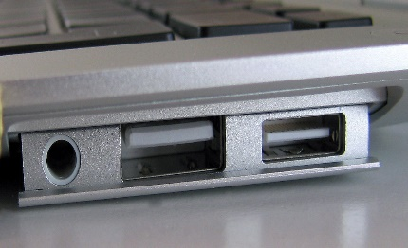

**Display Port**

Display Port is a digital display interface with optional multiple channel audio and other forms of data. Display Port is developed with an aim of replacing VGA and DVI ports as the main interface between a computer and monitor.

The latest version DisplayPort 1.3 can handle a resolution up to 7680 X 4320.

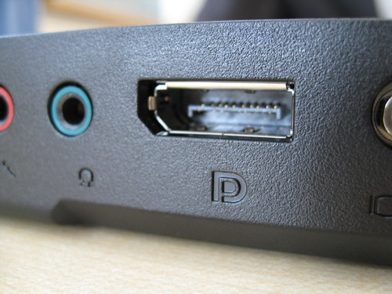

The Display Port has a 20 pin connector, which is a very less number when compared to DVI port and offers better resolution. The pin out diagram of a Display Port is shown below.

[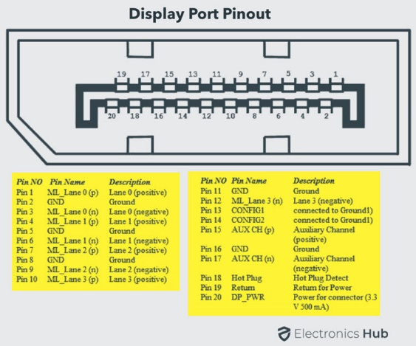](https://www.electronicshub.org/wp-content/uploads/2021/04/Display-Port-Pinout.jpg)

**Update:** DisplayPort 1.4a is the latest (in production) version of DisplayPort Specification with support for 4K (3840 x 2160) at 120 Hz or 8K (7680 x 4320) at 60 Hz. An improved DisplayPort version 2.0 specification is released in June of 2019 with an increased bandwidth of 77.37 Gbps (approximately).

**Mini DisplayPort**

Apple introduced a miniature version of DisplayPort and called it Mini DisplayPort (mDP or Mini DP). Even though Mini DisplayPort has 20 pins, the physical size of the connector is smaller than a regular DisplayPort and the pin out is also different.

[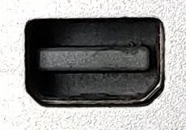](https://www.electronicshub.org/wp-content/uploads/2016/01/Mini-DisplayPort.jpg)

Most laptops provide Mini DisplayPort as an additional video out option in addition to HDMI.

**RCA Connector**

RCA Connector can carry composite video and stereo audio signals over three cables. Composite video transmits analogue video signals and the connector is as yellow colored RCA connector.

The video signals are transmitted over a single channel along with the line and frame synchronization pulses at a maximum resolution of 576i (standard resolution).

The red and white connectors are used for stereo audio signals (red for right channel and white for left channel).

[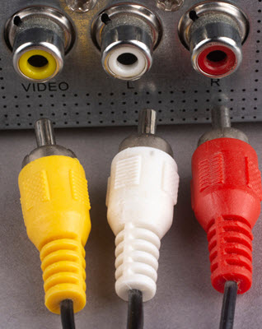](https://www.electronicshub.org/wp-content/uploads/2016/01/RCA-Port.jpg)

**Component Video**

Component Video is an interface where the video signals are split into more than two channels and the quality of the video signal is better that Composite video.

Like composite video, component video transmits only video signals and two separate connectors must be used for stereo audio. Component video port can transmit both analogue and digital video signals.

The ports of the commonly found Component video uses 3 connectors and are color coded as Green, Blue and Red.

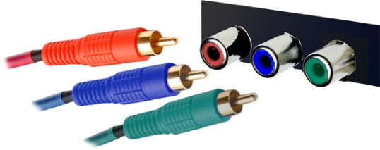

**S-Video**

S-Video or Separate Video connector is used for transmitting only video signals. The picture quality is better than that of Composite video but has a lesser resolution than Component video.

The S-Video port is generally black in color and is present on all TVs and most computers. S-Video port looks like a PS/2 port but consists of only 4 pins.

[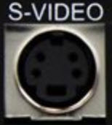](https://www.electronicshub.org/wp-content/uploads/2016/01/S-Video.jpg)

Out of the 4 pins, one pin is used to carry the intensity signals (black and white) and other pin is used to carry color signals. Both these pins have their respective ground pins. The pinout diagram of an S-Video port is shown below.

**[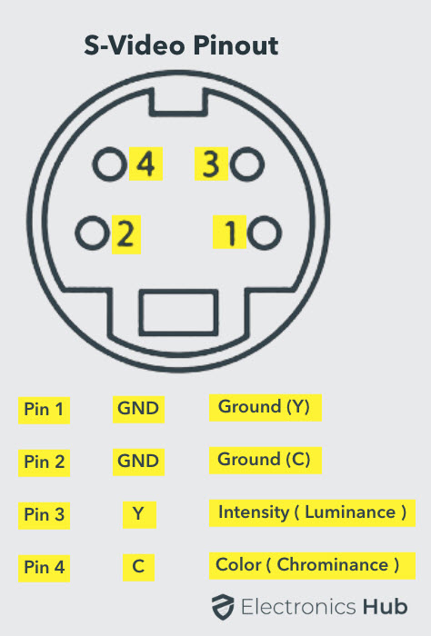](https://www.electronicshub.org/wp-content/uploads/2021/04/S-Video-Port-Pinout.jpg)**

**HDMI**

HDMI is an abbreviation of High Definition Media Interface. HDMI is a digital interface to connect High Definition and Ultra High Definition devices like Computer monitors, HDTVs, Blu-Ray players, gaming consoles, High Definition Cameras etc.

HDMI can be used to carry uncompressed video and compressed or uncompressed audio signals. The HDMI port of type A is shown below.

[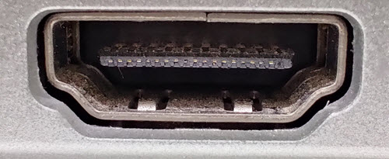](https://www.electronicshub.org/wp-content/uploads/2016/01/HDMI-Port.jpg)

The HDMI connector consists of 19 pins and the latest version of HDMI i.e. HDMI 2.0 can carry digital video signal up to a resolution of 4096×2160 and 32 audio channels. The pinout diagram of an HDMI port is as follows.

[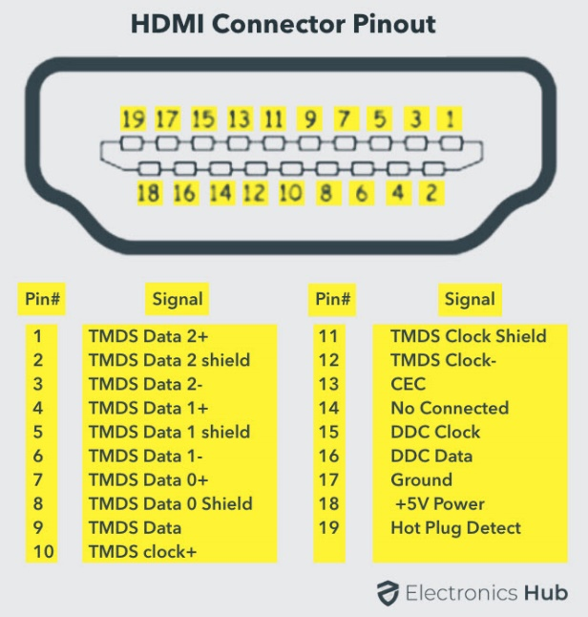](https://www.electronicshub.org/wp-content/uploads/2021/04/HDMI-Port-Pinout.jpg)

**Update:** The latest version of HDMI is 2.1 with much improved bandwidth, resolution and support from video card manufacturers. While HDMI 2.0 has a data bandwidth of 18 Gbps, the HDMI 2.1 has a staggering 48 Gbps of bandwidth. Coming to the display resolution, HDMI 2.1 supports 4K and 8K at 120 Hz refresh rate. Most modern (at least high end) graphics cards like Nvidia RTX 3090 provide at least a couple of HDMI 2.1 Ports to connect with monitors and TVs.

**Mini HDMI**

With HDMI 1.3 Version, a new HDMI Port and Connector combination is released called the Mini HDMI. Physically, it is smaller than a regular HDMI Port but has same 19 Pin. Intended for portable devices like laptops, cameras, camcorders, the Mini HDMI Port isn’t that popular.

**Micro HDMI**

HDMI developers introduced a new HDMI Connector and Port called Micro HDMI with HDMI Version 1.4. Micro HDMI also has 19 pins (just like regular HDMI and Mini HDMI) but the pinout is different.

Micro HDMI is often used in cameras, single board computers (like Raspberry Pi 4), etc. where physically it is difficult to include a regular HDMI port.

[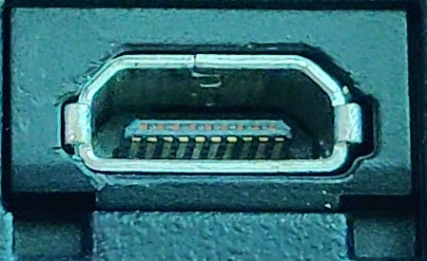](https://www.electronicshub.org/wp-content/uploads/2016/01/Micro-HDMI-Port.jpg)

The size of Micro HDMI is significantly smaller than regular HDMI and has some resemblance to a micro–USB Port (sometimes people confuse among the two). The port on the left is a micro USB port and the one on the right is a micro HDMI Port.

[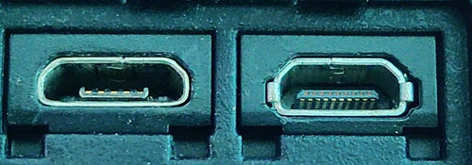](https://www.electronicshub.org/wp-content/uploads/2016/01/Micro-USB-and-Micro-HDMI.jpg)

**USB**

Universal Serial Bus (USB) replaced serial ports, parallel ports, PS/2 connectors, game ports and power chargers for portable devices.

USB port can be used to transfer data, act as an interface for peripherals and even act as power supply for devices connected to it. There are three kinds of USB ports: Type A, Type B or mini USB and Micro USB.

**USB Type A**

USB Type-A port is a 4 pin connector. There are different versions of Type – A USB ports: USB 1.1, USB 2.0 and USB 3.0. USB 3.0 is the common standard and supports a data rate of 400MBps.

USB 3.1 is also released and supports a data rate up to 10Gbps. Usually, but not all the times, the USB 2.0 is Black color coded and USB 3.0 is Blue. The following image shows USB 2.0 and USB 3.0 ports.

[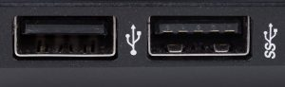](https://www.electronicshub.org/wp-content/uploads/2016/01/USB-2.0-and-USB-3.0.jpg)

The pinout diagram of USB Type – A port is shown below. The pinout is common to all standards of Type – A.

[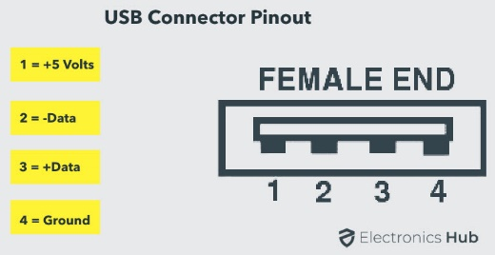](https://www.electronicshub.org/wp-content/uploads/2021/04/USB-Type-A-Connector-Pinout.jpg)

**USB Type C**

USB Type – C is the latest specification of the USB and is a reversible connector. USB Type – C is supposed to replace Types A and B and is considered future proof.

[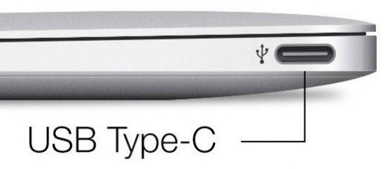](https://www.electronicshub.org/wp-content/uploads/2016/01/USB-Type-C.jpg)

The port of USB Type – C consists of 24 pins. The pinout diagram of USB Type – C is shown below. The latest USB Specifications (USB4) is an USB-C only specification i.e., only USB type C devices can be used with USB4 specifications.

[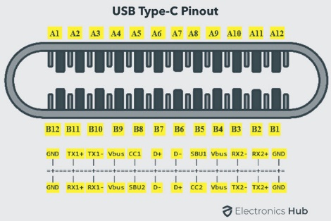](https://www.electronicshub.org/wp-content/uploads/2021/04/USB-Type-C-Port-Pinout.jpg)

In the latest USB4 specification, USB Type C Devices can support speeds up to 40 Gbps.

USB Power Delivery specifications allow USB devices to supply power to devices connected to the USB Port. USB Type – C can handle a current of 5A at 20V (only Power Delivery certified USB Type-C Ports).

This feature of handling high current is used in the latest Fast Charging Technology where a Smart Phone’s battery will reach its full charge is very less time. So, USB Type C Ports can provide up to 100W of power (which can be used for charging mobile phones and laptops).

In fact, the latest Apple M1 Mac Books use 61W USB C Power Adapter.

**RJ-45**

Ethernet is a networking technology that is used to connect your computer to Internet and communicate with other computers or networking devices.

The interface that is used for computer networking and telecommunications is known as Registered Jack (RJ) and RJ – 45 port in particular is used for Ethernet over cable. RJ-45 connector is an 8 pin – 8 contact (8P – 8C) type modular connector.

The latest Ethernet technology is called Gigabit Ethernet and supports a data transfer rate of over 10Gigabits per second. The Ethernet or a LAN port with 8P – 8C type connector along with the male RJ-45 cable is shown below.

The un-keyed 8P – 8C modular connector is generally referred to the Ethernet RJ-45. Often, RJ-45 ports are equipped with two LEDs for indicating transmission and packet detection.

[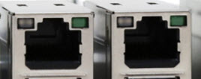](https://www.electronicshub.org/wp-content/uploads/2016/01/RJ45-Port.jpg)

As mentioned earlier, an Ethernet RJ-45 port has 8 pins and the following picture depicts the pinout of one.

[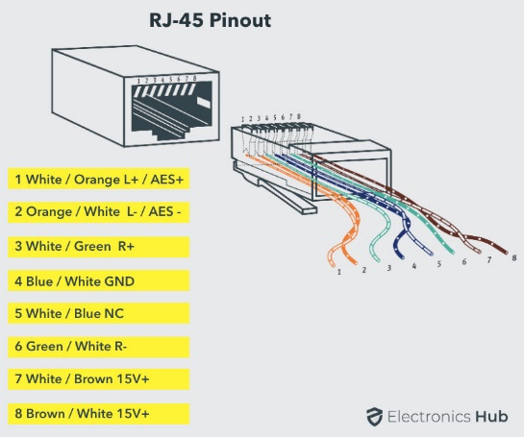](https://www.electronicshub.org/wp-content/uploads/2021/04/RJ-45-Connector-Pinout.jpg)

**RJ-11**

RJ-11 is another type of Registered Jack that is used as an interface for telephone, modem or ADSL connections. Even though computers are almost never equipped with an RJ-11 port, they are the main interface in all telecommunication networks.

RJ-45 and RJ11 ports look alike but RJ-11 is a smaller port and uses a 6 point – 4 contact (6P – 4C) connector even though a 6 point – 2 contact (6P – 2C) is sufficient. The following is a picture of an RJ-11 port and its compatible connector.

[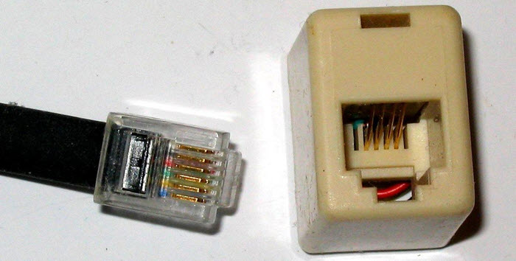](https://www.electronicshub.org/wp-content/uploads/2016/01/RJ11-Port-and-Connector.jpg)

The following image can be used to compare RJ-45 and RJ-11 ports.

**e-SATA**

e-SATA is an external Serial AT Attachment connector that is used as an interface for connecting external mass storage devices. Modern e-SATA connector are called e-SATAp and stands for Power e-SATA ports.

They are hybrid ports capable of supporting both e-SATA and USB. Neither the SATA organization nor the USB organization has officially approved the e-SATAp port and must be used at user’s risk.

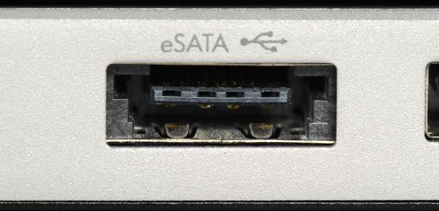

The above image is of an e-SATAp port. It shows that both e-SATA and USB devices can be connected.

**SPECIFICATION OF DESKTOP AND SERVER CLASS COMPUTERS**

### PC Desktop Hardware Specifications

* **Motherboard:** Gigabyte B560M-DS3H Motherboard
* **Power Supply:**Scaled appropriately to support delivered system with reasonable growth potential (In Win CE685 PC case with 300 watt 80PLUS certified power supply)
* **Case:**In Win CE685 PC case with 300 watt 80PLUS certified power supply
* **CPU:** Intel Core i5-11400 Processor
* **RAM:**8GB DDR4 2666 (PC4 21333) RAM (1 8GB DIMM)
* **NIC:**On-board 10/100/1000 Mbps based Ethernet NIC
* **HDD:** 250 GB Western Digital M.2 NVMe SSD Part # WDS250G2B0C
* **Video:**Integrated Intel HD Graphics with DVI Digital Output Interface
* **Optical Drive:** (optional)
* **Audio:** Onboard HD audio
* **Externally powered Satellite Speakers:**(optional)
* **6 External Powered USB Ports and 2 on front of case**
* **Operating System:**Microsoft Windows 7 Home Basic(or other least expensive Microsoft Windows operating system)
* **All appropriate cables necessary**
* **HIDs:** USB Optical mouse, mouse pad, USB keyboard, all necessary cables
* **3 year parts and labor warranty on all components**
* **Monitor:** 20″ Wide Screen LCD Monitor (1920×1080 native resolution) with DVI Digital Input Interface

### 

### PC Laptop Specifications

There is currently 1 laptop model specified for new purchases

* Intel Core i5-1135G7 Processor
* 8GB DDR4 2666 RAM
* 250 GB M.2 NVMe Solid State Drive
* 15.6″ Wide Screen Display
* Microsoft Windows Windows 7 Pro(or other least expensive Microsoft Windows operating system)
* On board 10/100/1000 Mbps Ethernet NIC
* On board Wireless NIC
* On board HD Audio
* 2 External powered USB Ports
* Padded Carry Case appropriate for delivered model
* Appropriate American Power Conversions Notebook Surge Suppressor for delivered model
* All appropriate cables necessary
* 3 year parts and labor warranty on all components

**Server Classes**

When multithreaded operating system processes are not available, a good alternative is to use a set of processes to emulate a pool of threads. That is, instead of having one [multithreaded process](https://www.sciencedirect.com/topics/computer-science/multithreaded-process), the system uses a set of single-threaded processes, all of which are running the same program (see Figure 2.8). This often is called a **server class**. In this case, for each server program, there is a set of server processes that runs it.

